**Pre-Experiment Setup A**

Follow the next instructions in order to have a SPL example running. Next you will be required to make some modifications or additions.

**FOR THIS EXPERIMENT YOU NEED TO HAVE INSTALLED:**

* Java (JDK)
* VariaMos
* Eclipse Oxygen EE
* Apache Tomcat

**CONFIGURING VARIAMOS:**

1. Go to this link: <https://mega.nz/#!7Q4wXSrC!R1E4IeYvzJnt2gaMKFT2zJJYjBxtWy_3qnTecKplEyY> and download all the content
2. Decompress Stores.zip inside a folder called “Stores”
   1. This folder contains the pool of components, derivation folder and the VariaMos model
3. Open VariaMos (Component-based project)
4. Go to File -> Load File and load the storesmodel.vmum

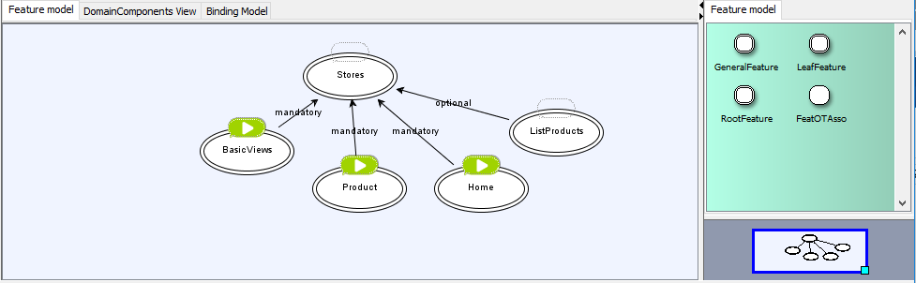

1. Go to “Domain Implementation” -> “Set derivation parameters” and configure the proper paths based on your location

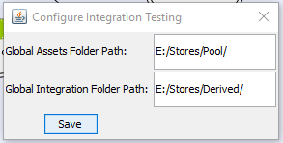

1. Click “Execute Derivation” you will see a message like this (verify that the “derived folder” contains content inside: folders and files):

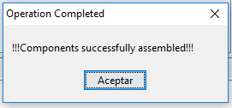

**CONFIGURING ECLIPSE:**

1. Open Eclipse Oxygen. File -> New -> Dynamic Web Project (Called Stores1)

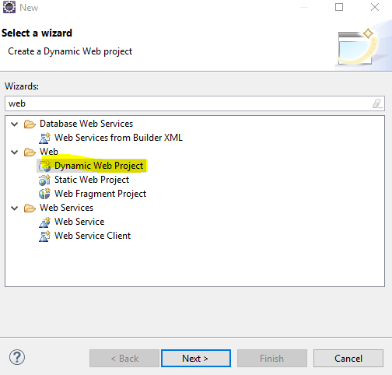

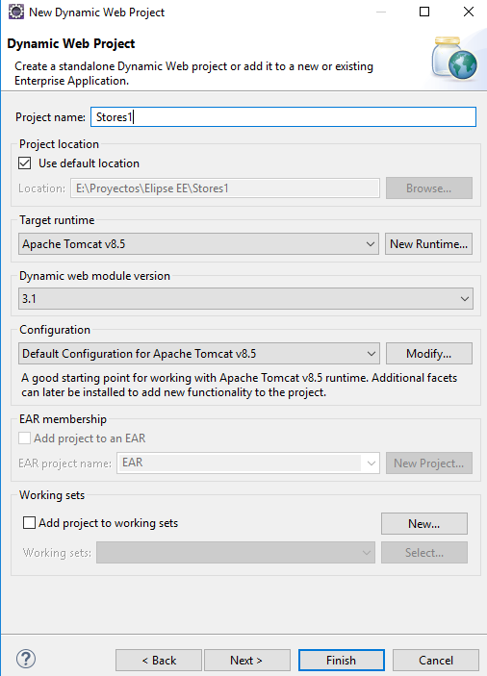

1. Download JSTL (Jar version) <https://mvnrepository.com/artifact/javax.servlet/jstl/1.2>

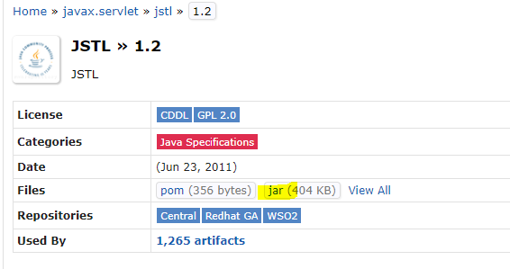

1. Include the previous file (jstl-1.2.jar) inside the WebContent/WEB-INF/lib/ folder

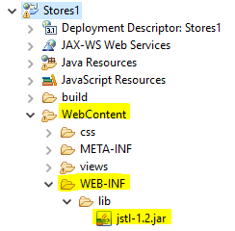

1. Go to your project root folder (right click over your project -> properties)

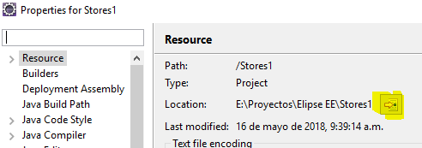

1. Copy the derived folders, inside you project root folder (check next image):

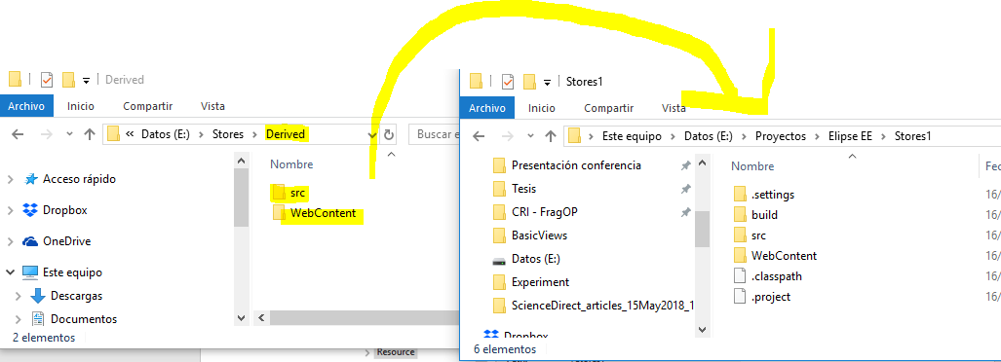

1. Refresh your project (right click over the project -> refresh). You will see the new folders and files added inside the project.

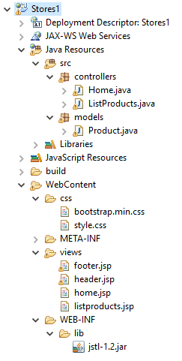

1. Right click over your project -> Run as -> Run on Server -> Select Tomcat -> Finish
   1. It will show you a new URL and a message saying HTTP 404. Similar to this:

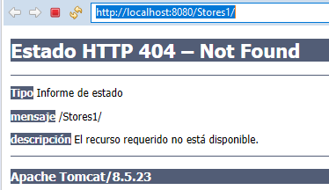

* 1. Add the word “Home” at the end of the URL and the application should load like this:

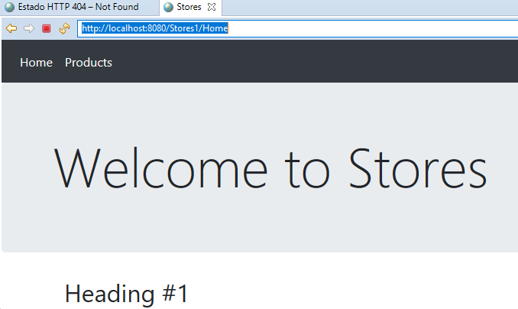

* 1. NOTE: we recommend to copy and paste that link in Google Chrome or Firefox to have a proper view of the application.

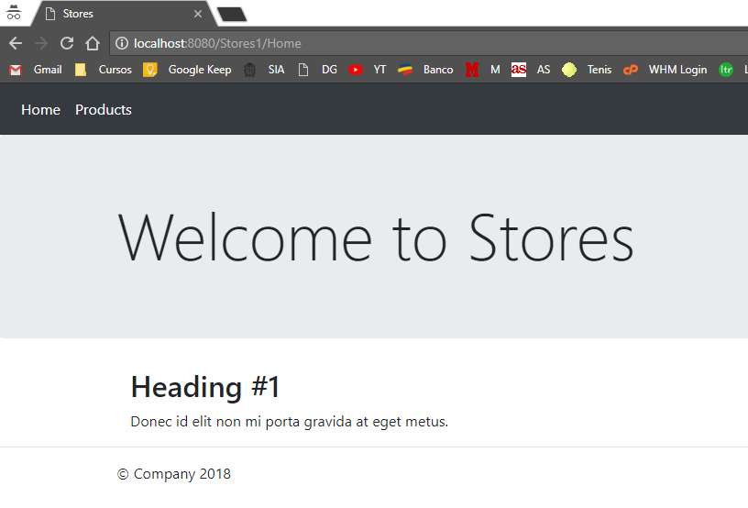

**¡¡CONGRATS YOU HAVE SET UP PROPERLY THE EXPERIMENT!!**